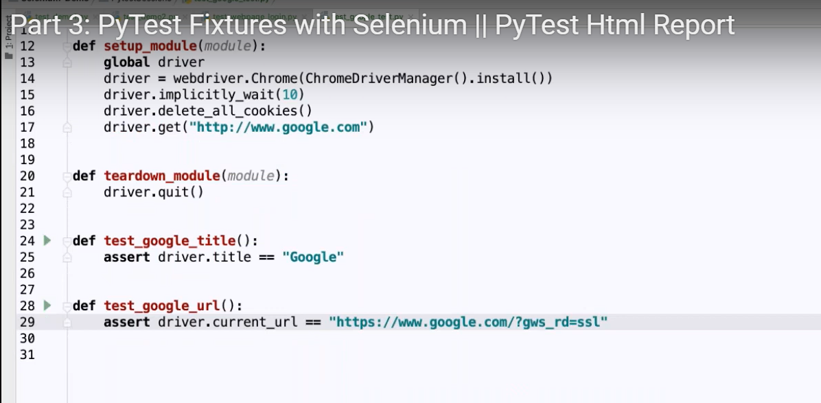



To run above code -v means more verbose on console -s if any print statement present





To generate pytest html report we need to install and run above code

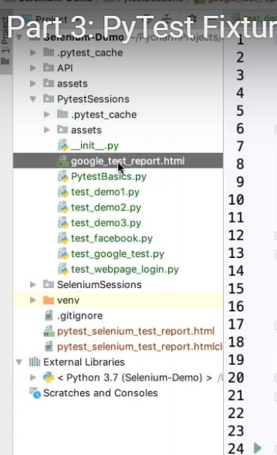

Generated in below location

Fixture

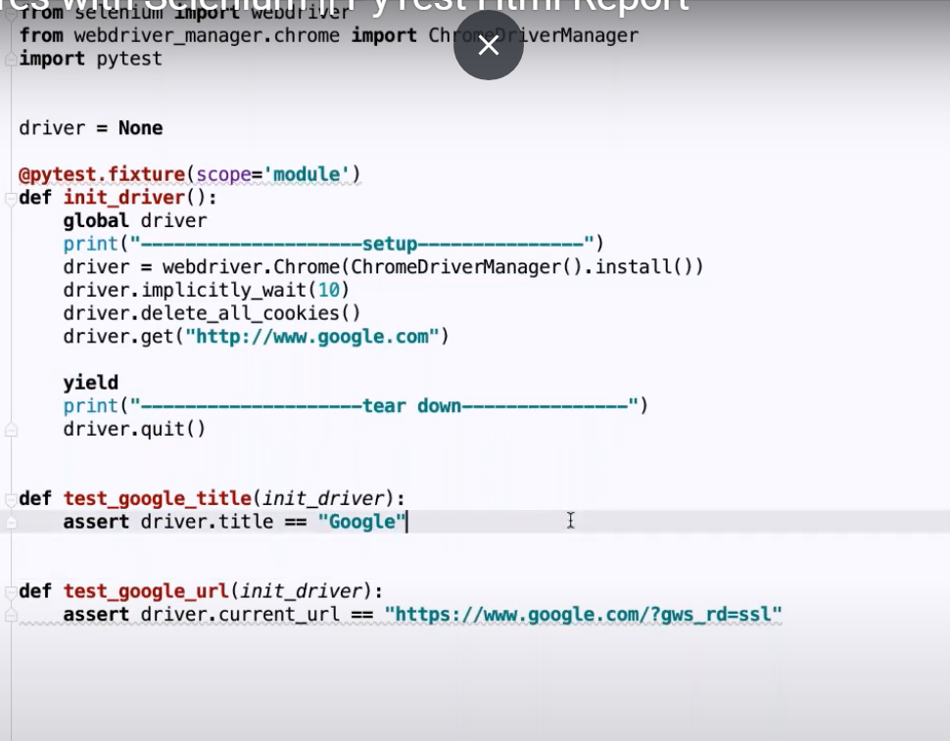



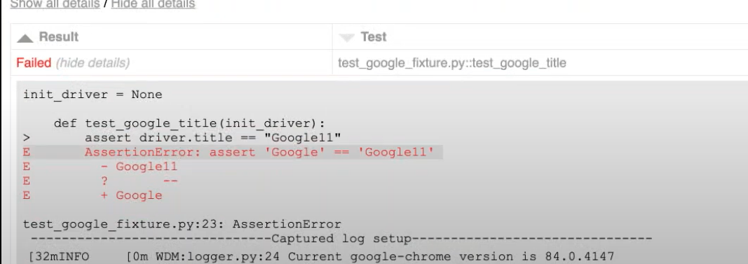



Scope is class

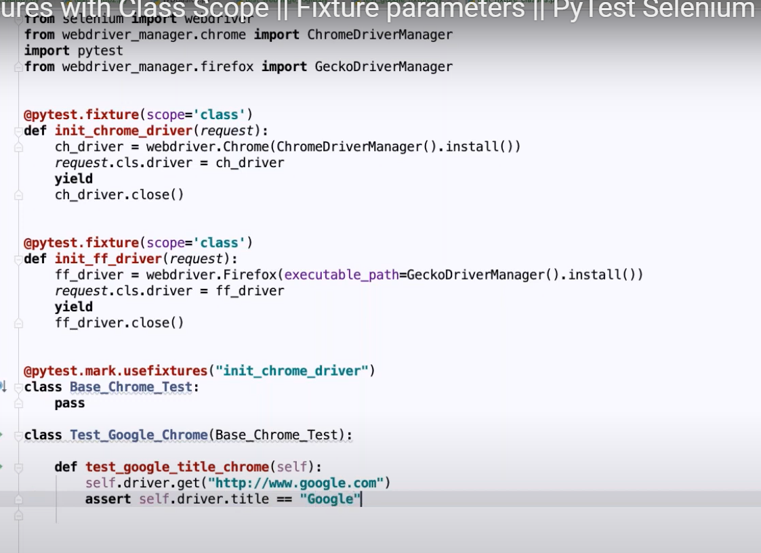

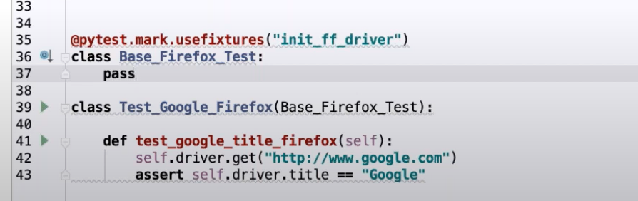



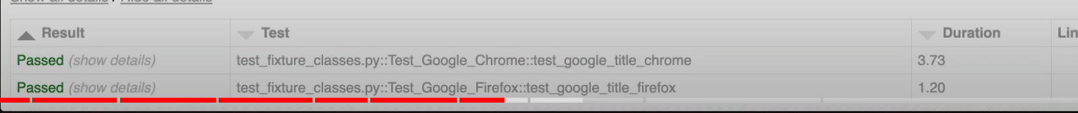

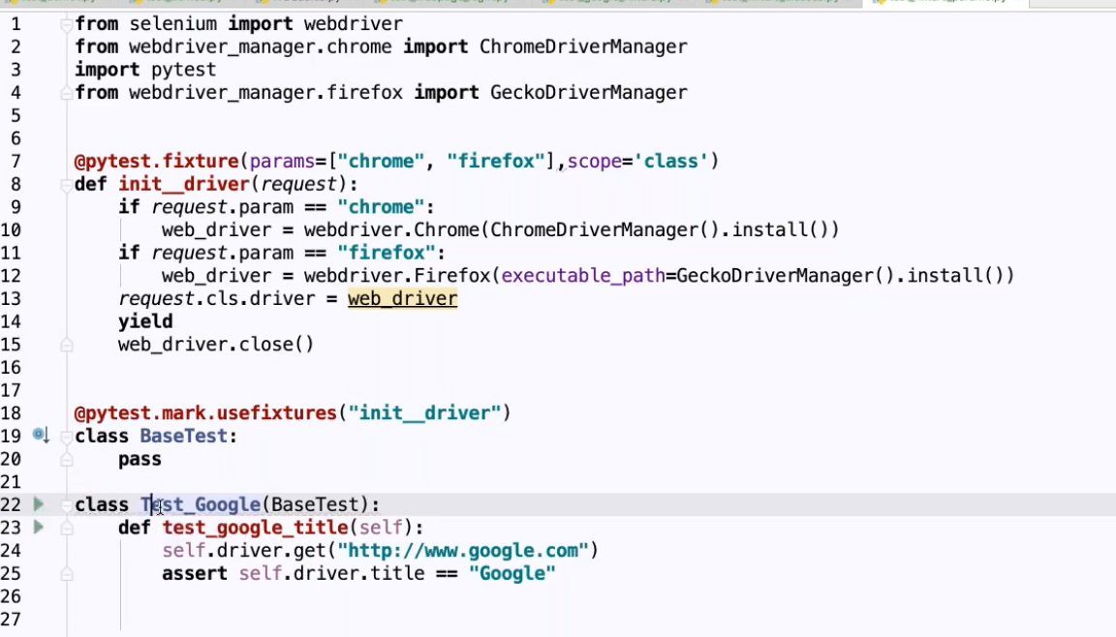



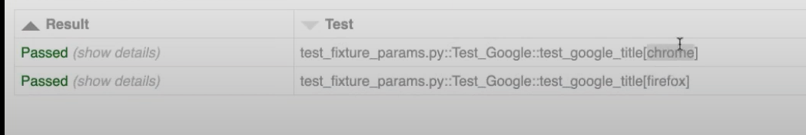

Parameters name executes same test cases with 2 different parameters



For parallel execution with 2 thread

File name should be conftest

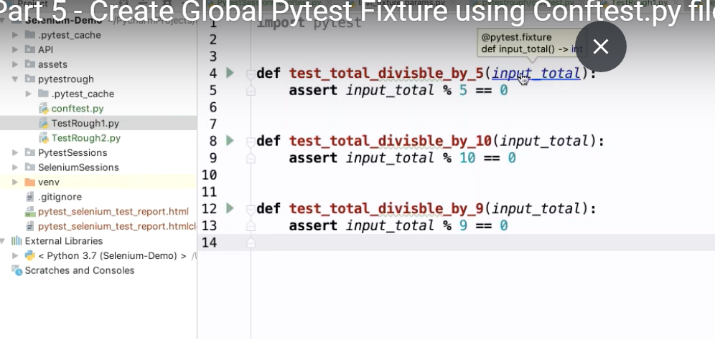

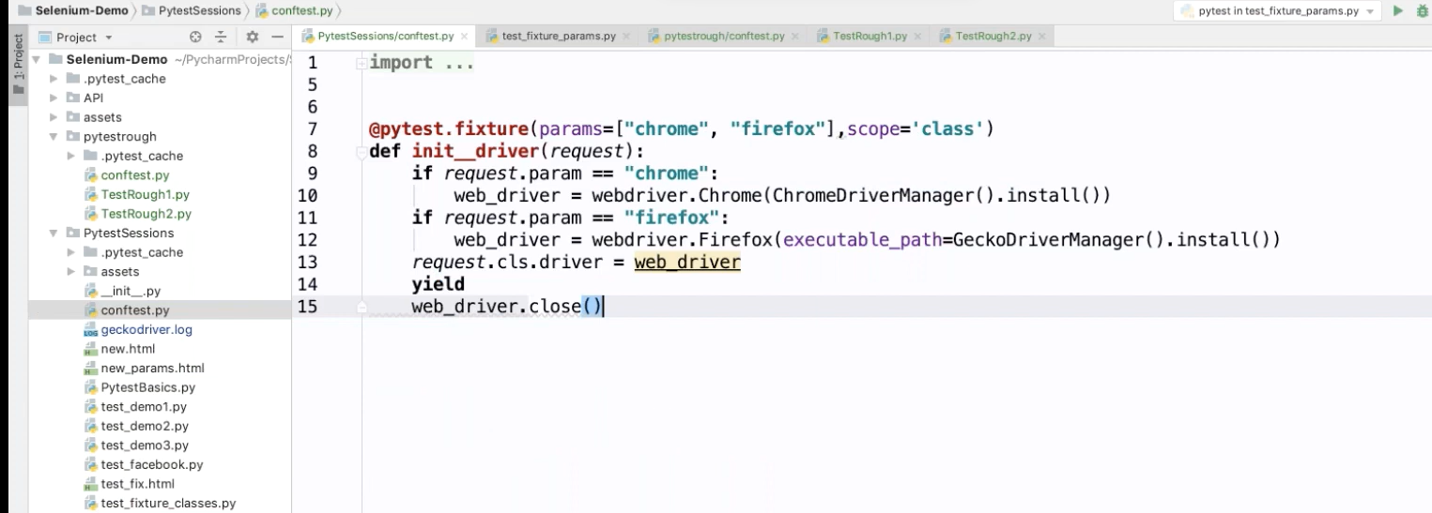

By using coftest.py we are going to create global precondition and if we want to use in any class we need to pass method name

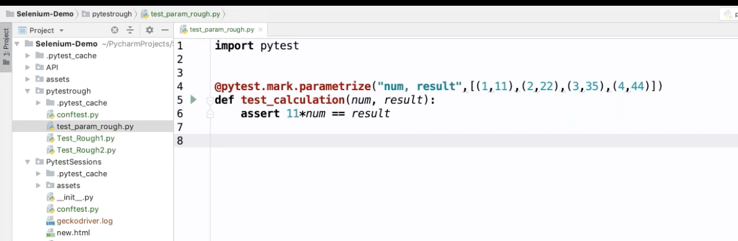

Parametrization

